USER MANUAL

FOR

YOUTH NETWORKS AND ORGANISATIONS DATABASE, DASHBOARD AND MAPPING WEBSITE IN
MALAWI

Table of Contents
- Introduction………………………………………………………………..3
- Accessing the website…..…..........................................................………...4
2.1. Overview dashboard...……..............................................................…4
2.2. Quick links…............................................................................…...…..4
2.2. Login…….…............................................................................…...…...4
- Data entry portal………..........................................................….………...4
3.1. Login process………………………………………………………….4
3.2. Navigating the dashboard…………………………………………….4
3.3.Adding new entry………………………………………………………5
3.4. Uploading data via CSV………………………………………………6
3.5. Downloading data……………………………………………………..6
3.6. Submitting data………………………………………………………..6
- Distribution of youth organizations….…………………………………...5
- User and system settings management……………………………………8
- System adminstration……………………………………………………..10

Introduction
This manual provides instructions for using the newly developed website for mapping and profiling youth networks and organizations in Malawi. The system integrates a database, dashboard, and mapping tool designed to enhance data management, visualization, and collaboration among stakeholders.

Accessing the Website
The landing page serves as the central hub for accessing the system's features. It includes:
Overview Dashboard:
- A responsive map and interactive charts showcasing key metrics for youth organizations and networks.
- Filtering options allow you to click on a district on the map to refine the data displayed in the charts.
Quick Links:
- Access other sections of the system directly, including:
    - Youth Organizations Locations
    - Login
Overview Dashboard
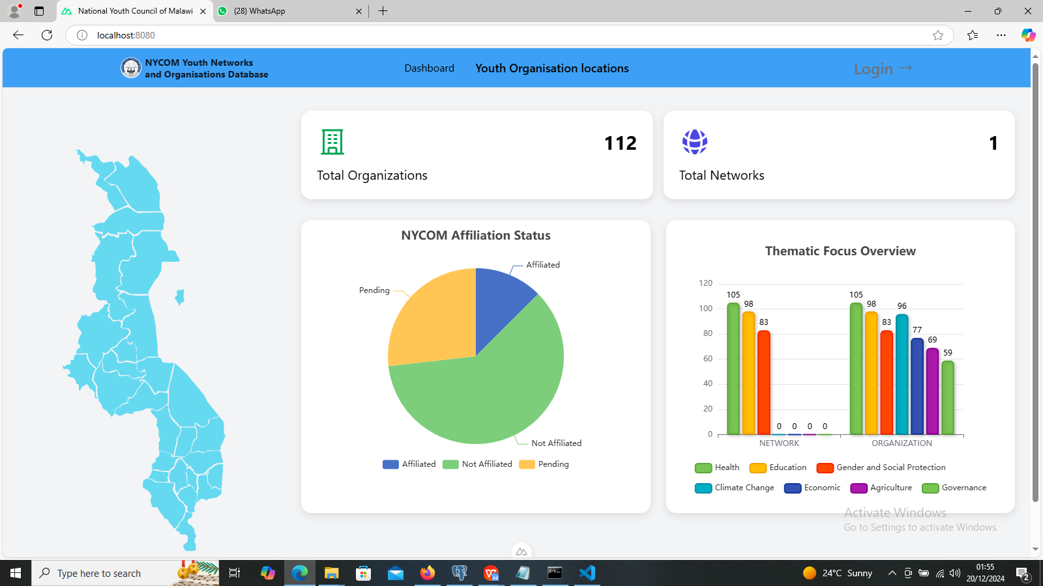

Login:

Navigate to the Login link available on the Dashboard.

Enter your username and password.

Login Page
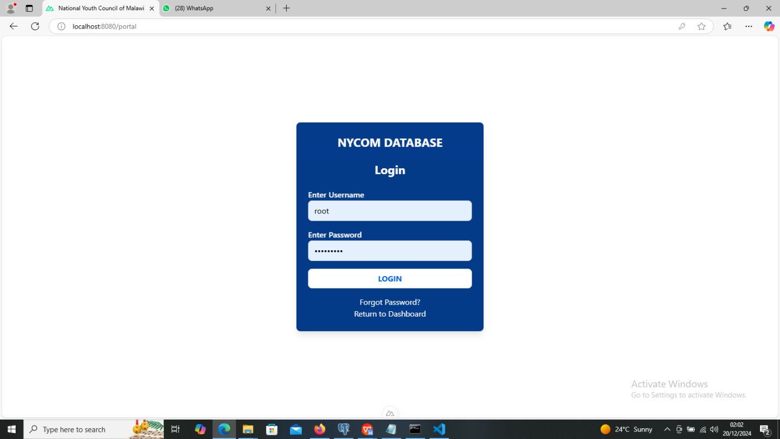

Two types of users can log in:

Data Clerks: Enter and manage data in the database.

Managers: Review, edit data entries, and manage user accounts.

Data Entry (For Data Clerks):
Login Process:
- After logging in, you will be directed to the data entry interface.
Navigating the Dashboard:
- Click on the card for either the Total Number of Networks or the Total Number of Organizations.
- Selecting a card will take you to a page displaying the corresponding list.

Adding New Entries:
- On the top-right corner of the list table, locate the button labeled either "Add Network" or "Add Organization, depending on the card selected.
- Click this button to open a form.
- Fill out the form carefully, ensuring data accuracy and consistency.
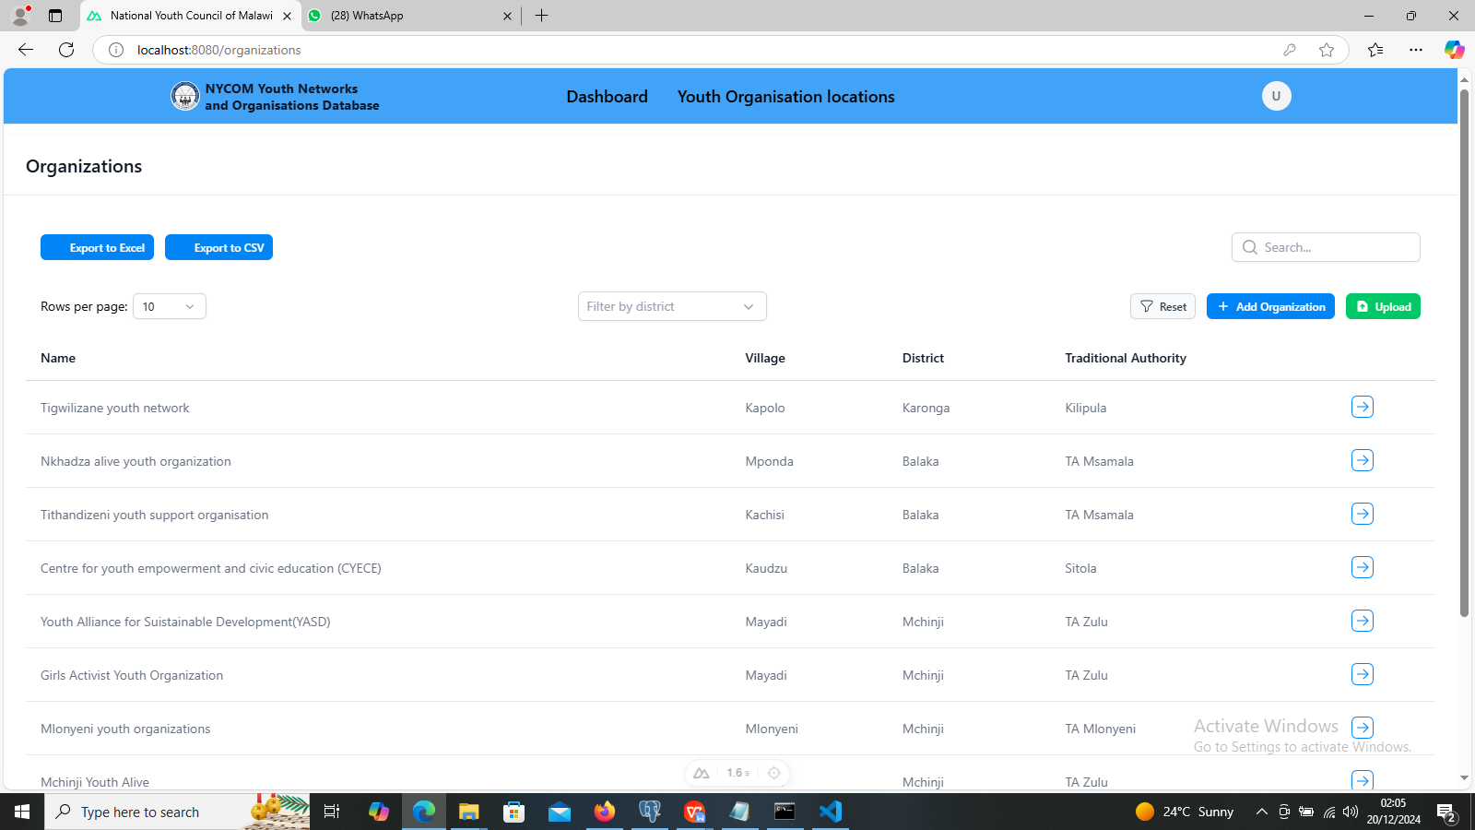

Uploading Data via CSV:
- There is an option to upload data from a CSV file.
- Ensure your collected data is in CSV format to avoid upload errors.
- Click the upload button, navigate to your file's location, and upload it.
Downloading Data:
- On the right-hand side, you'll find download buttons.
- Use these buttons to export the data in either Excel or CSV file formats, as required.
Submitting Data:
- After completing the form or uploading a CSV file, ensure all fields are filled correctly before submission.
- Once submitted, the data is saved to the centralized database.

Managing System Data for Data Entry:
- From the Settings page, you can also manage the following to assist data clerks:
- Traditional Authorities (TAs):
- Click on TAs to add new Traditional Authorities to the system.
- EPAs and Constituencies:
- Click on EPA or Constituencies to add new entries to the system, making them available for clerks during data entry.

Distribution of Youth Organizations
The Distribution of Youth Organizations section provides a detailed view of the locations and profiles of youth organizations across Malawi. This feature is accessed by clicking the Youth Organizations Locations link on the Dashboard.

Features:
Interactive Map:
- Once you click the Youth Organizations Locations link, you will be directed to a map of Malawi displaying the distribution of youth organizations.
- Click on any map point to view detailed information about the corresponding organization.
Map with Youth Organization Points
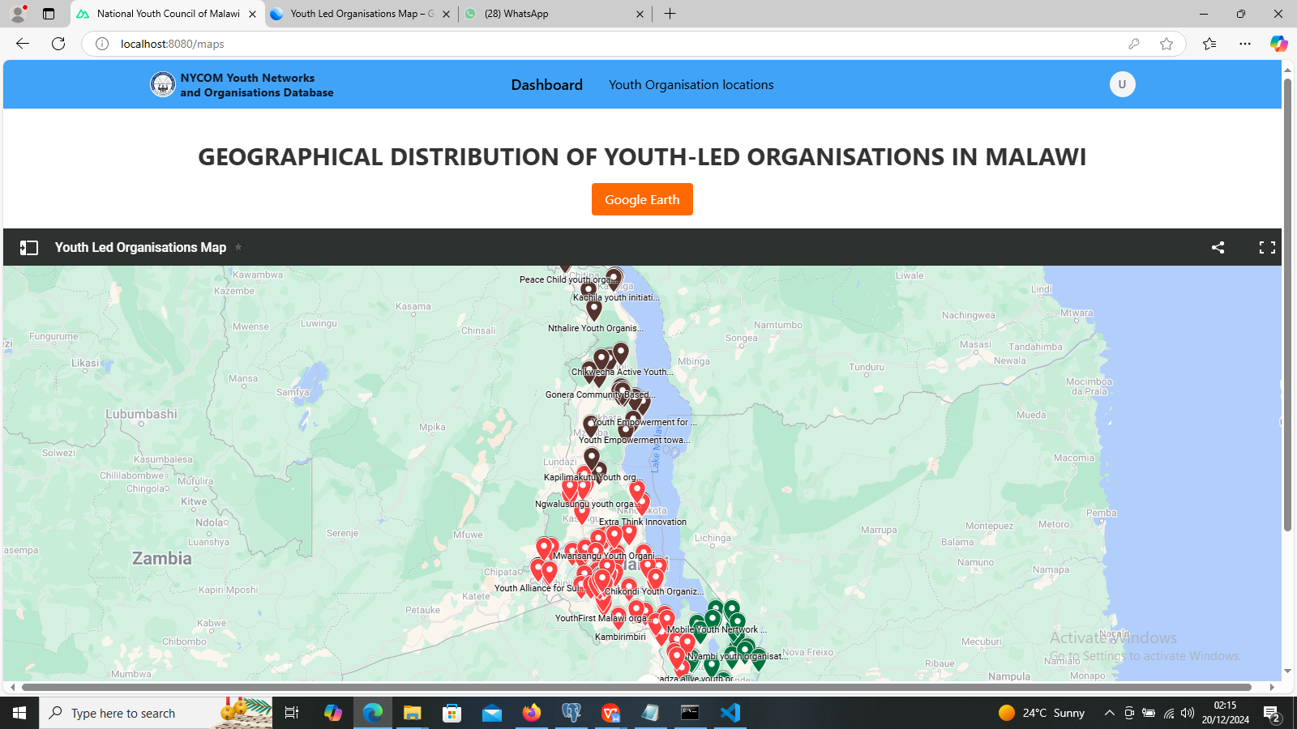
Viewing Topographic Features:
- Use the Google Earth button located at the top of the map to explore topographic features of each organization's location.
- After Google Earth loads, regions with their respective organization names will be displayed.
Navigating Google Earth:
- Use the dropdown menu to select the name of the organization you want to view.
- Double-click the organization's name to zoom in to its location.
- The zoomed-in view will reveal detailed features at the organization's location, including buildings, roads, and surrounding topographic details.

Google Earth Interface with Example Organization Location
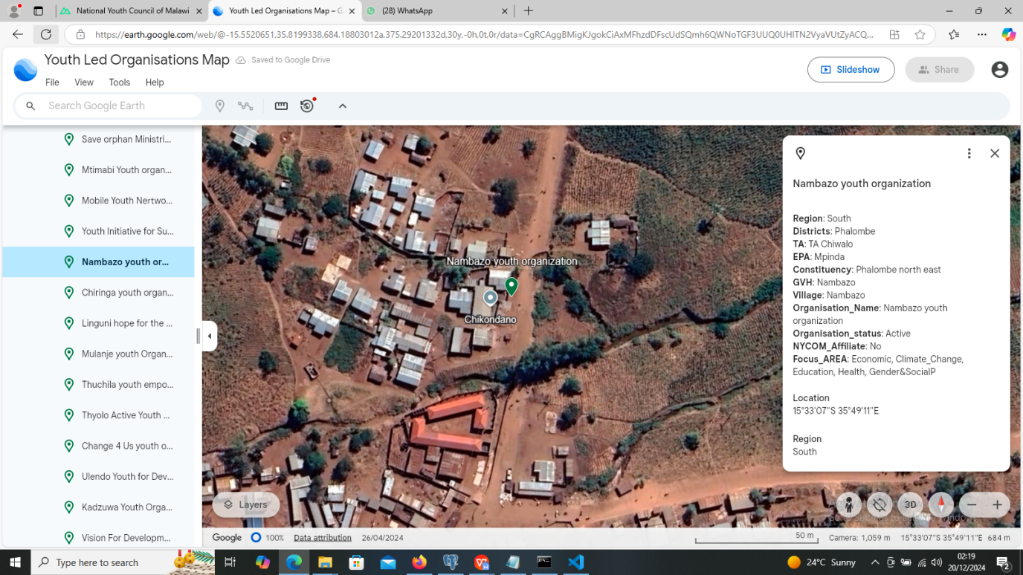
Organization Profiles:
- On the right-hand side of the Google Earth page, a detailed profile of the selected organization is displayed. This profile includes additional information about the organization

Organization Profile on Google
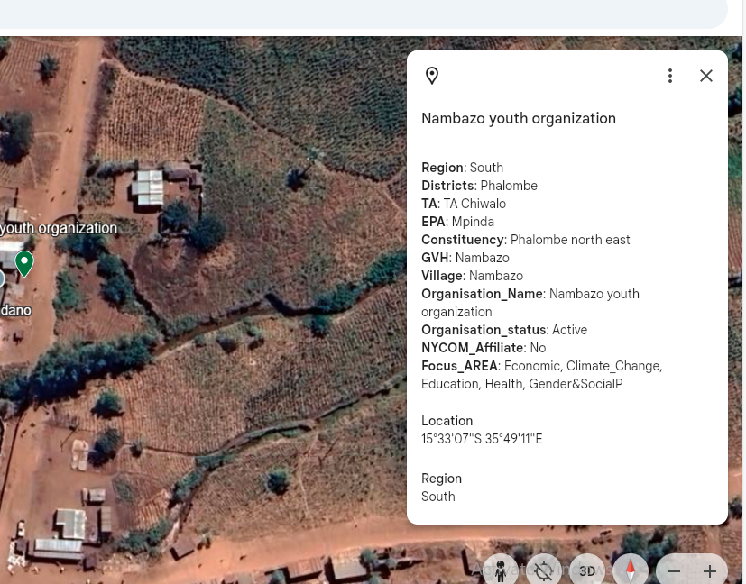

User and System Settings Management (For Managers):
Accessing Settings:
- After logging in, click on the user avatar located at the top-left corner of the navigation bar.
- Select Settings from the dropdown menu.
Settings
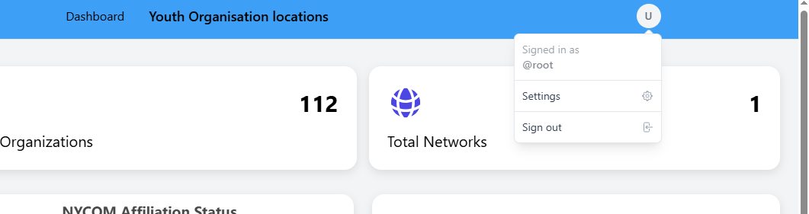

Managing User Accounts:
- In the Settings page, click on Users to:
- Add new user accounts.
- Modify existing accounts.
- Deactivate unnecessary accounts.
User Management Interface
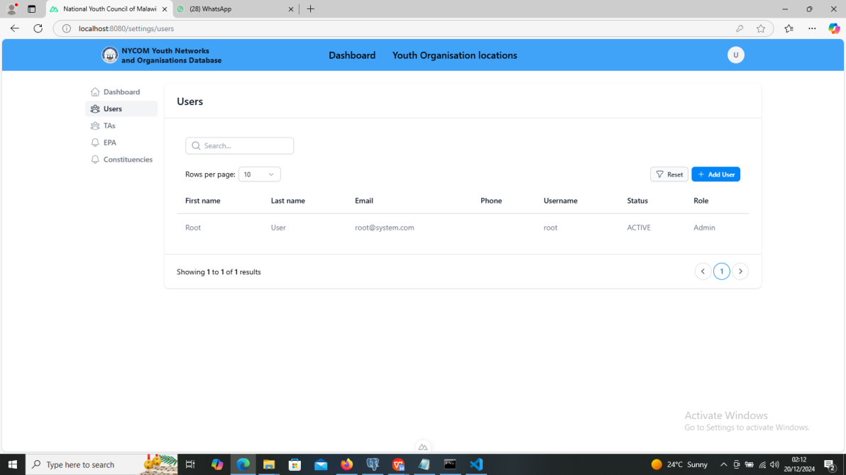

System Administration
Database Maintenance:
- Regularly back up the database to ensure data safety.
- Monitor system logs to detect and resolve issues promptly.
System Updates:
- Periodically update the system to integrate new features or improvements.

Troubleshooting
Login Issues:
- Ensure you are using the correct username and password.

Login Error Example
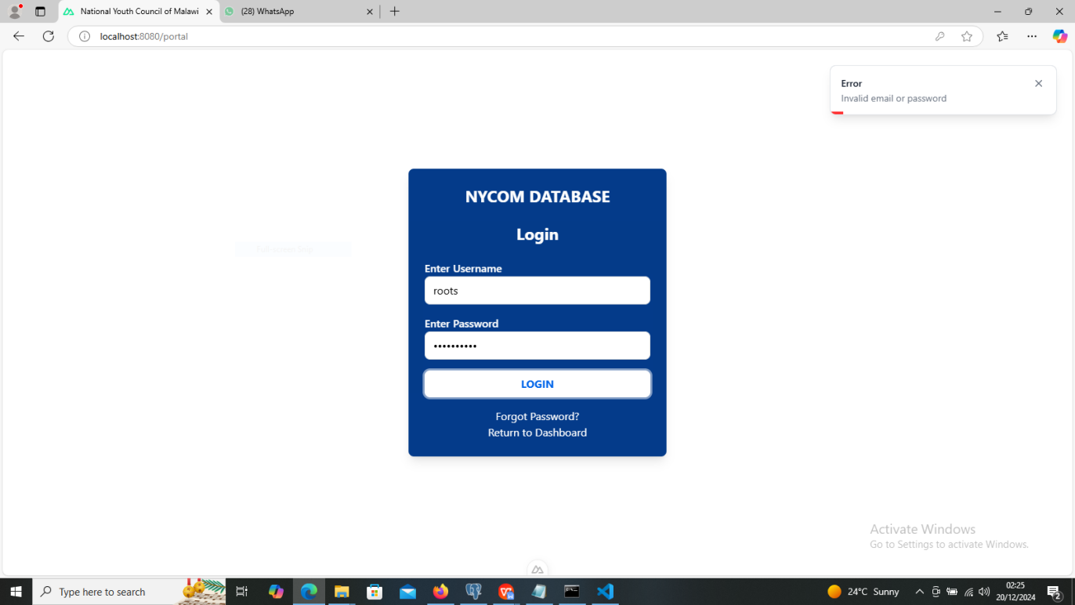

- If the problem persists, contact the system administrator for assistance.
Data Entry Errors:
- Check data formatting and completeness before submitting.
- For persistent errors, report the issue to technical support.
Map Display Issues:
- Clear your browser cache or try accessing the map using a different browser.

Support
For assistance or inquiries, please contact:
Martin Chirwa
Email: martinchirwa92@gmail.com
Phone: 0993924775 / 0883528202

